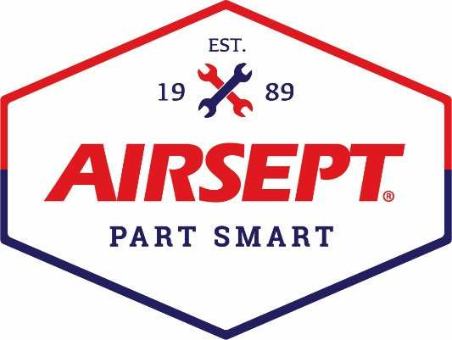

News Release

AirSept® Announces New Distribution Partnership with Transtar Industries®

Atlanta – August 1, 2023 – AirSept®, a leader in developing automotive solutions for complex repair problems, announces a new distribution partnership with Transtar Industries®. Transtar, founded in 1975, is the world’s largest supplier of transmission and driveline parts. Transtar recently launched a comprehensive line of air conditioning parts for auto, light duty, and medium duty applications.

AirSept, an innovation leader in developing unique, problem-solving products for the mobile and stationary HVAC markets, has been granted more than 40 patents worldwide and has received twenty industry awards for products designed to save time and labor and grow service profits.

With this partnership, Transtar will now stock AirSept’s unique and proprietary problem-solving products for the mobile air climate market including AirSept’s Smart Splice™ line repair solutions, Dual Recycle Guard™ to prevent sealant and contaminants from damaging A/C service equipment, Compressor Guard™ filters to protect compressors from harmful debris, and AirSept’s complete line of unique A/C tools and equipment.

AirSept President, Aaron Becker, says, “We are excited to announce a partnership with Transtar that will allow us to offer our extensive line of A/C repair solutions to a broad national market. Our innovative products are designed to provide new A/C repair options and to protect expensive A/C service equipment. Transtar is perfectly positioned for success in the A/C aftermarket, and we are proud to offer our products through them.”

Transtar Vice President of Product Development, Kevin Piekarski, says, “Our partnership with AirSept allows Transtar to get one step closer to our mission of simplifying complex vehicle repair to keep the world moving. AirSept’s innovative and unique products allow our customers to be more efficient and profitable and we are proud to be partnered with a company that matches our same passion for problem solving.”

For more information on AirSept’s full product line visit www.AirSept.com. For more information about Transtar Industries’ A/C product line visit here.

# # # #

Image Attached: 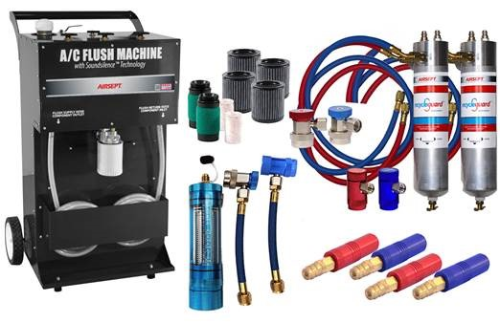

About AirSept®
In 1989 AirSept® created the first long-lasting solution to the problem of unwanted mold and mildew odor in automobile air conditioning systems. The product quickly became popular and in 1991 AirSept was incorporated as a company. AirSept began partnering with global OEMs and suppliers to not only market its Cooling Coil Coating, but to also develop other unique, new problem-solving products. From those humble beginnings, AirSept has grown to be the industry leader in the development of OEM and aftermarket solutions to complex automotive repair problems. AirSept products are designed to save time, money and labor. For more information, visit www.AirSept.com.

About Transtar Industries®:
Transtar Industries® is a global leader in transmission and driveline-related solutions. With over 70 locations in North America, Transtar is dedicated to providing customers with outstanding service, offering the broadest product catalog and best-in-class distribution of quality OE, aftermarket parts, and premium remanufactured products. Founded in 1975 in Cleveland, Ohio, Transtar is a global supplier of products related to the transmission and driveline, with a comprehensive offering that includes automatic and standard transmission units, transmission rebuild kits and components, remanufactured torque converters, hard parts, valve bodies, differentials, and transfer case kits and components, as well as a full line of air conditioning parts, components and tools. All products are available on their patent-winning ecommerce platform, www.Transend.us.

For further product information, contact:
Aaron Becker, President
AirSept
678-973-2287
abecker@airsept.com

Leslie Allen
Owner
Wildcat Communications
615-429-7965
leslieallen.wildcat@gmail.com

